**List of Python Programs for Assignment 1**

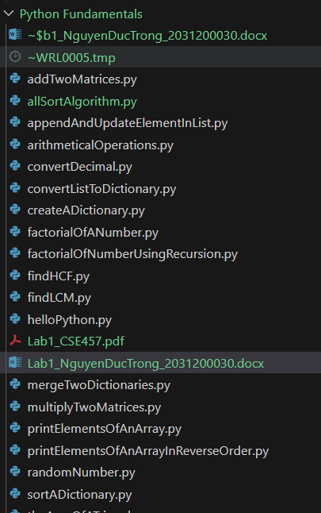

1. **Python program to print "Hello Python"**

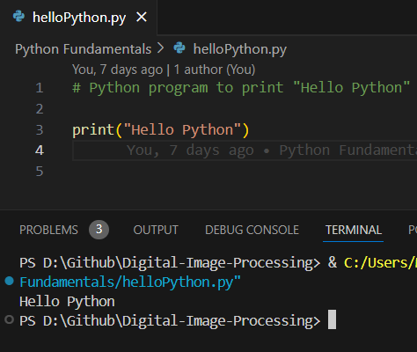

1. **Python program to do arithmetical operations**

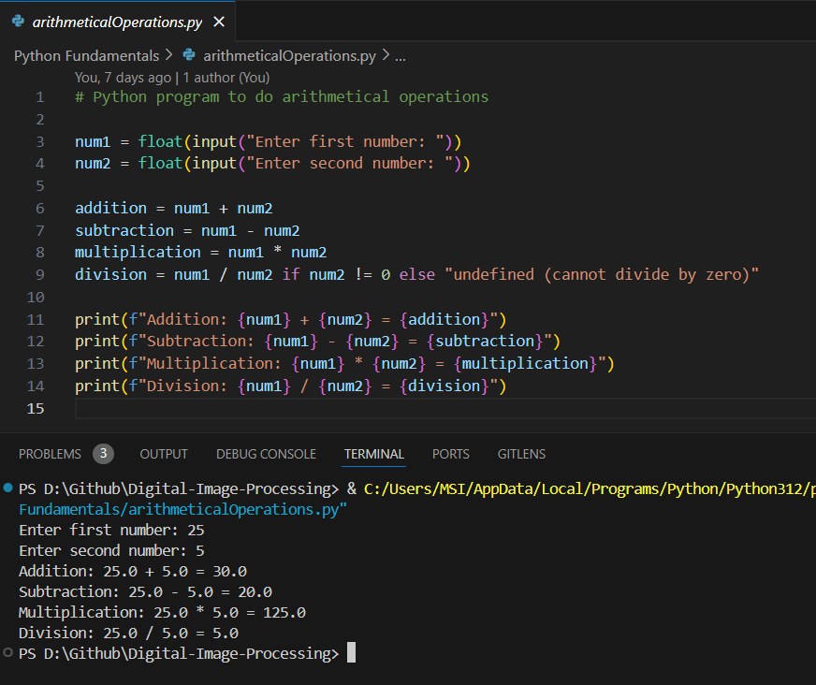

1. **Python program to find the area of a triangle**

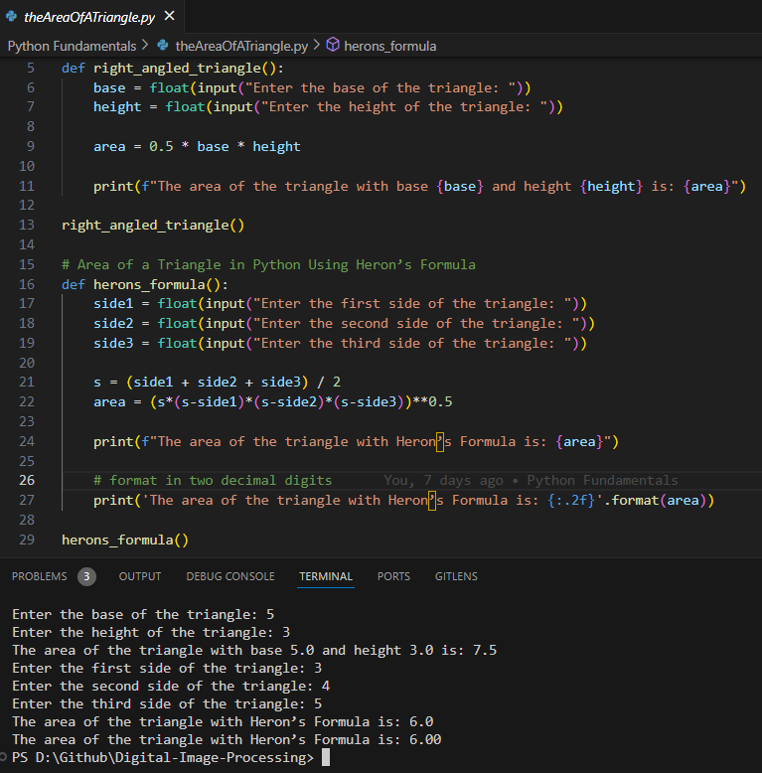

1. **Python program to generate a random number**

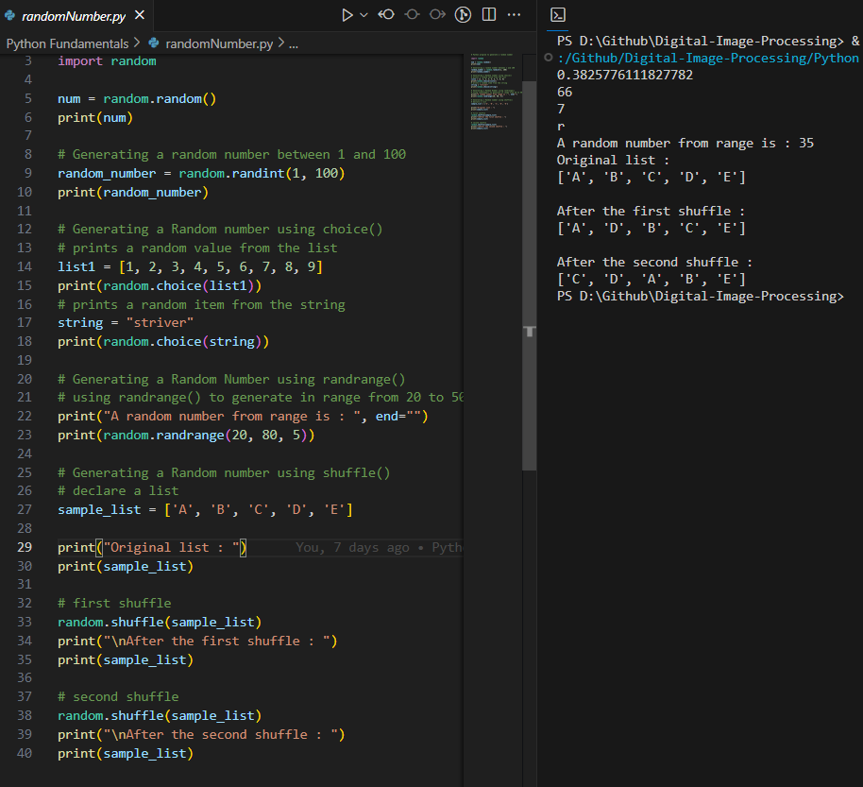

1. **Python Program to Find the Factorial of a Number**

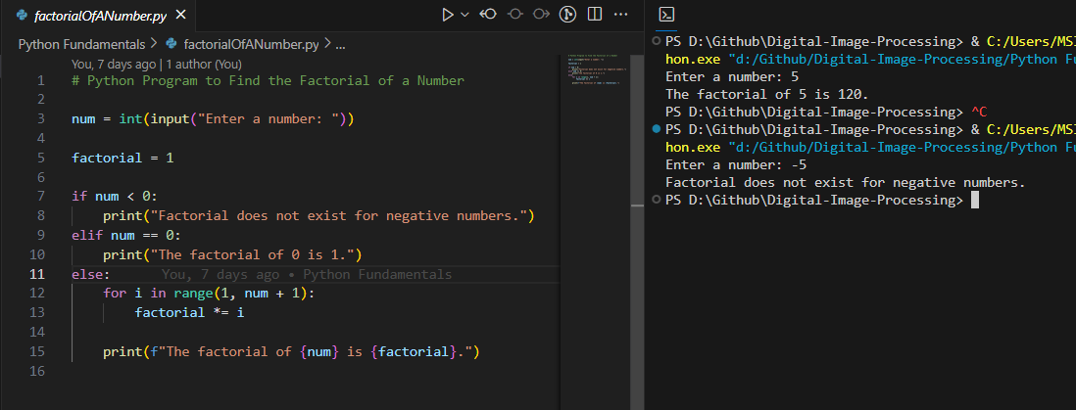

1. **Python Program to Find LCM**

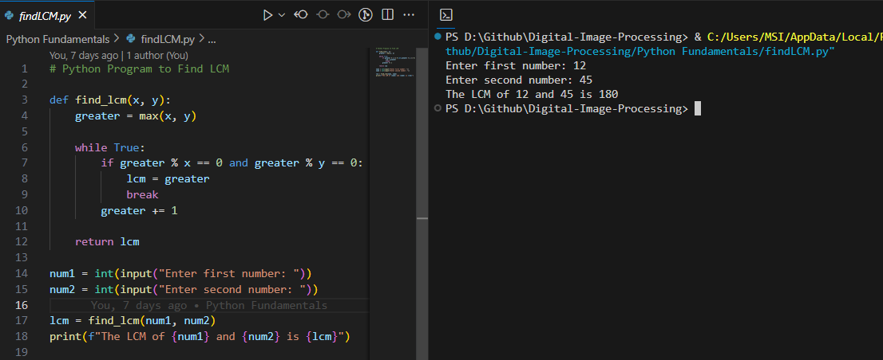

1. **Python Program to Find HCF**

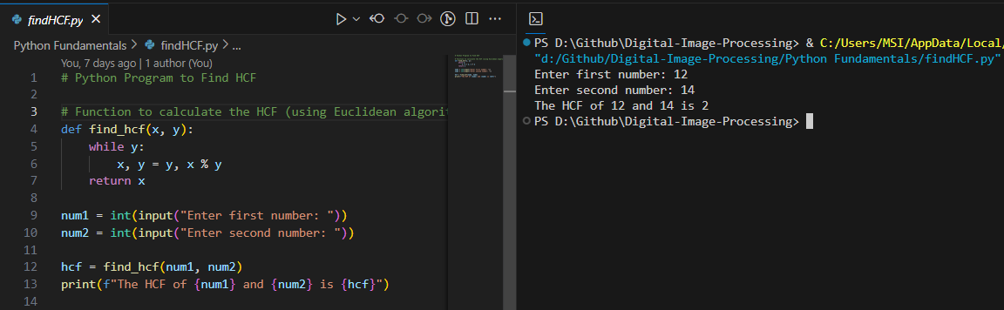

1. **Python Program to Convert Decimal to Binary, Octal and Hexadecimal**

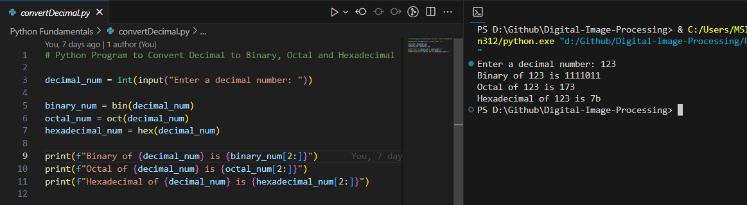

1. **Python Program to Find Factorial of Number Using Recursion**

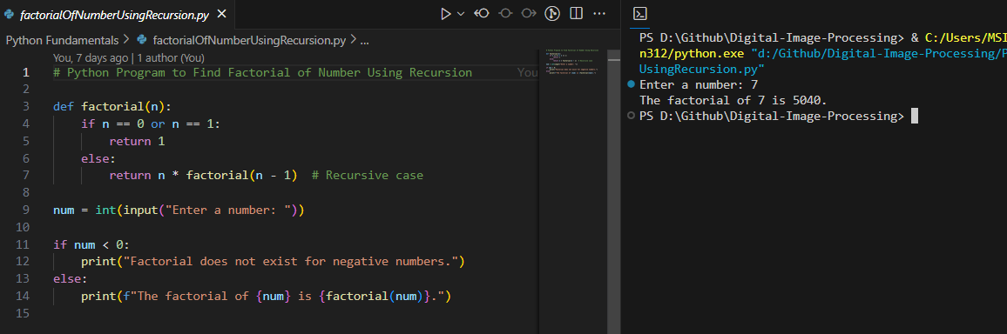

1. **Python program to print the elements of an array**

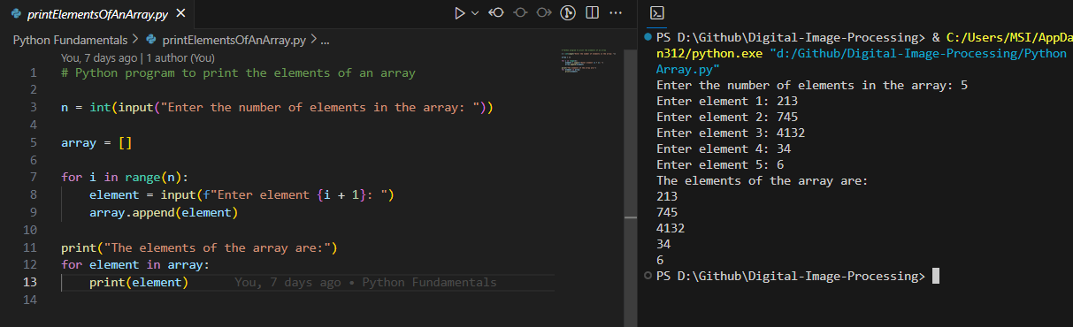

1. **Python program to print the elements of an array in reverse order**

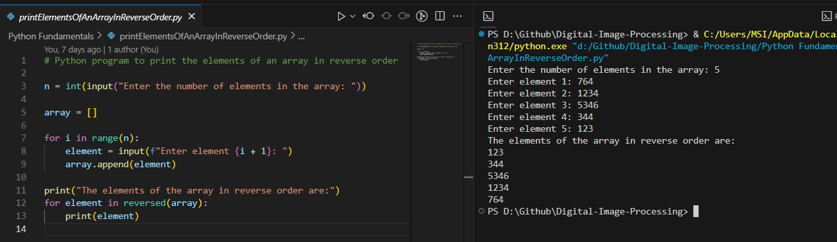

1. **Python Program to Add Two Matrices**

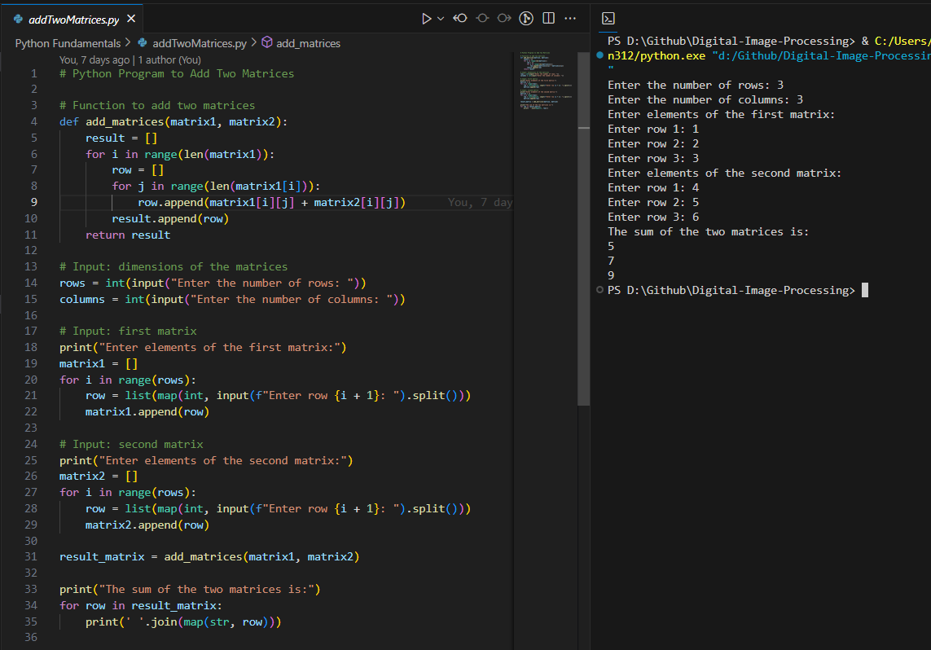

1. **Python Program to Multiply Two Matrices**

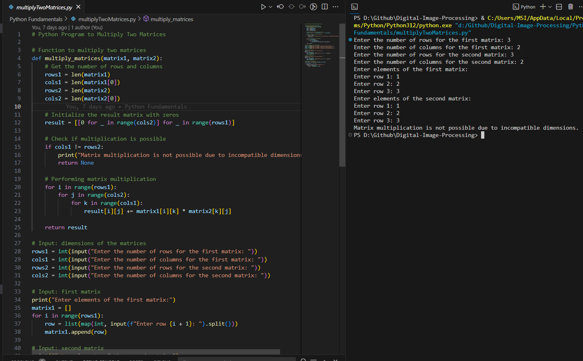

1. **Python Program to append element in the list and update list with insertion of elements, removing an element, comparison of two lists, etc.**

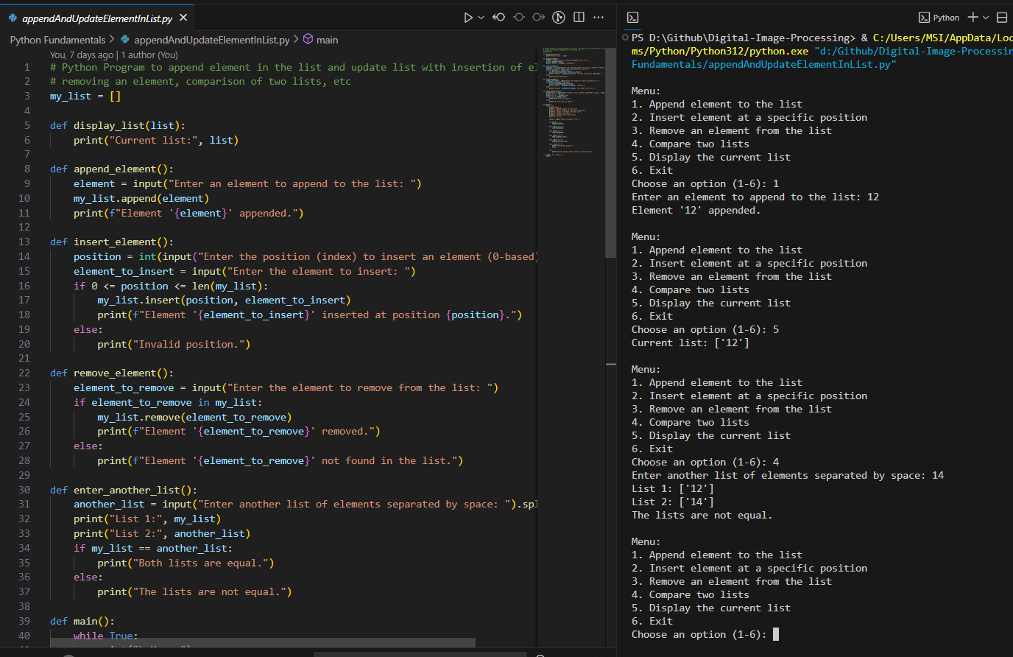

1. **Python Program to create a dictionary**

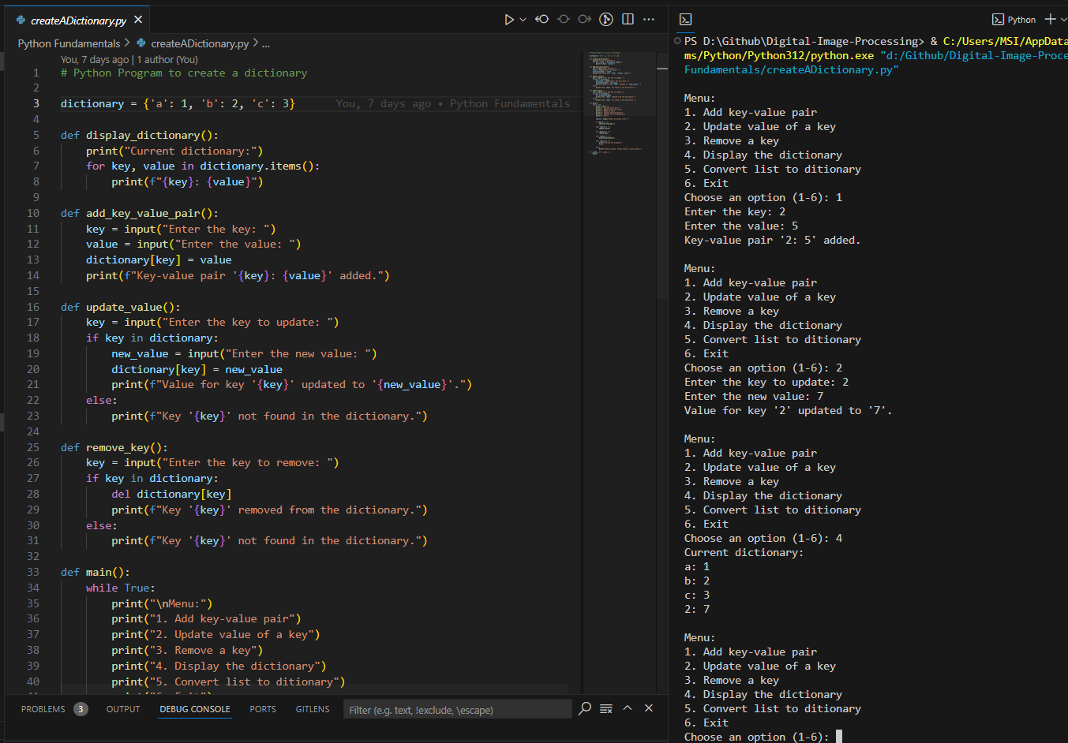

1. **Python Program to convert list to dictionary**

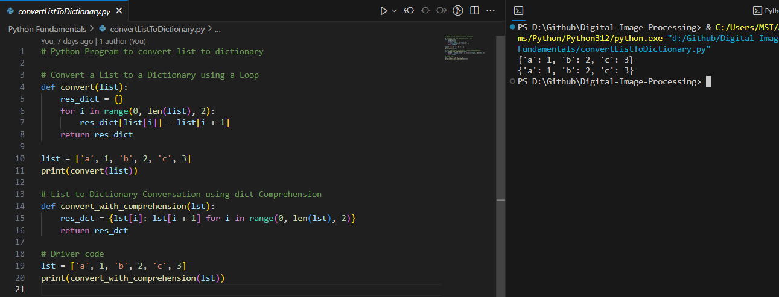

1. **Python Program to sort a dictionary**

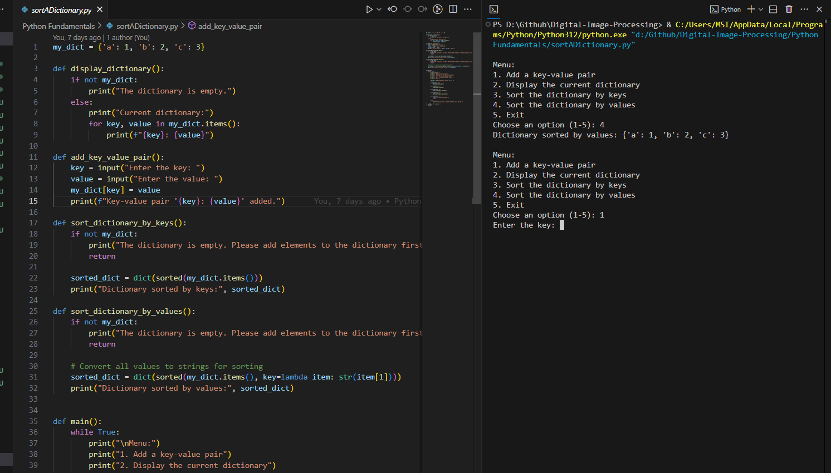

1. **Python Program to Merge two Dictionaries**

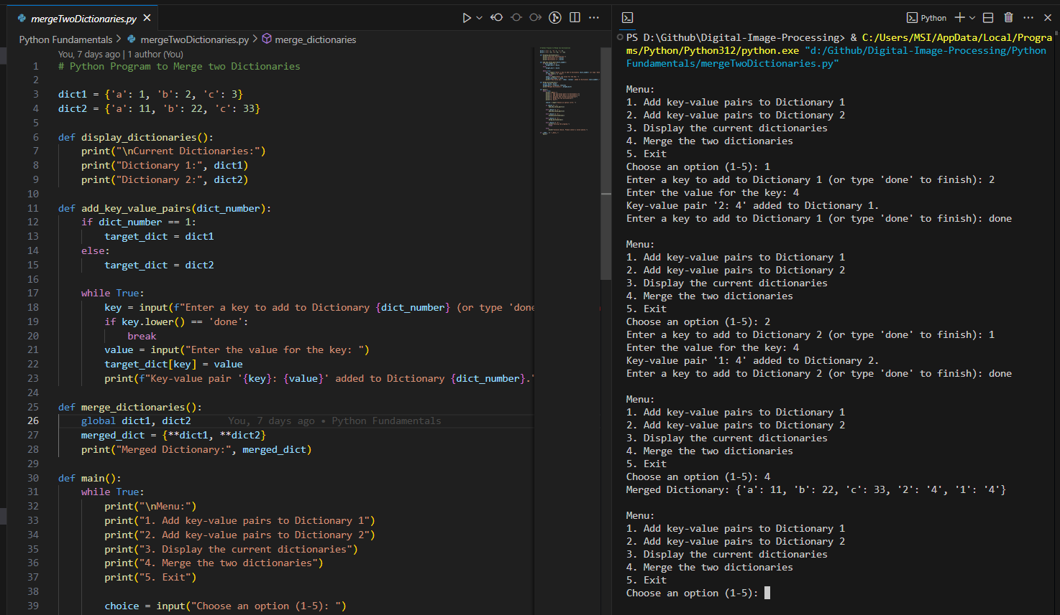

1. **Binary Search in Python**

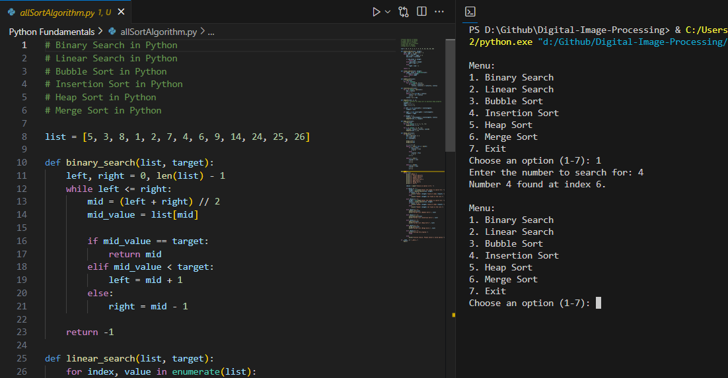

1. **Linear Search in Python**

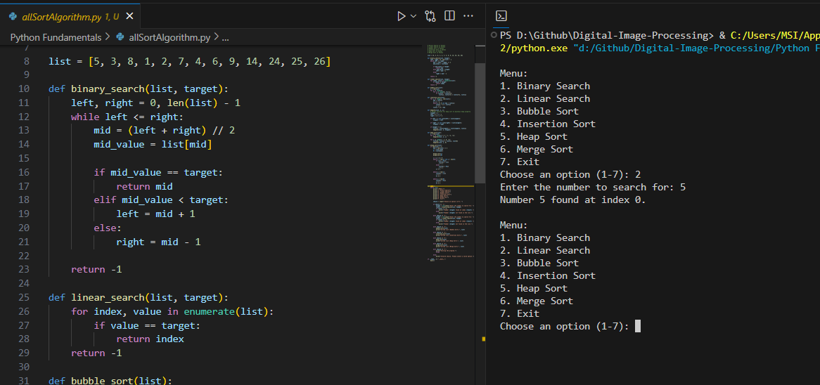

1. **Bubble Sort in Python**

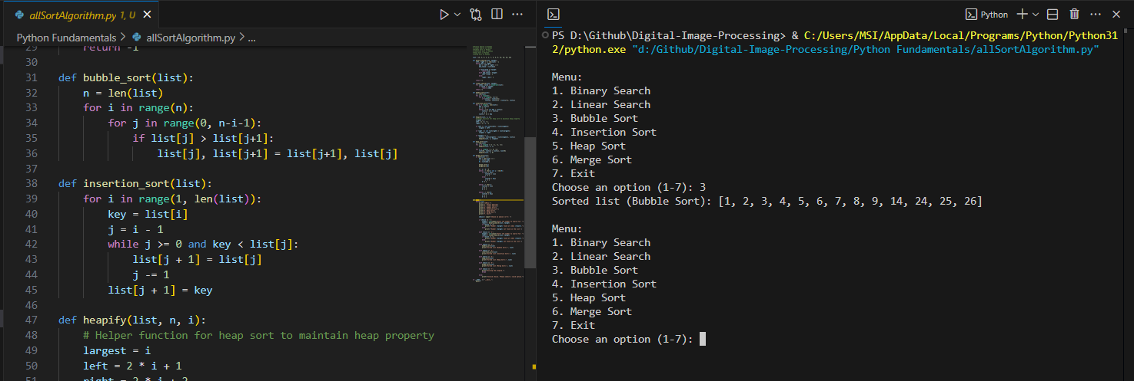

1. **Insertion Sort in Python**

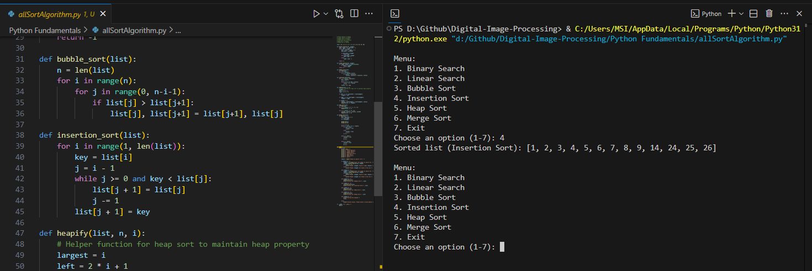

1. **Heap Sort in Python**

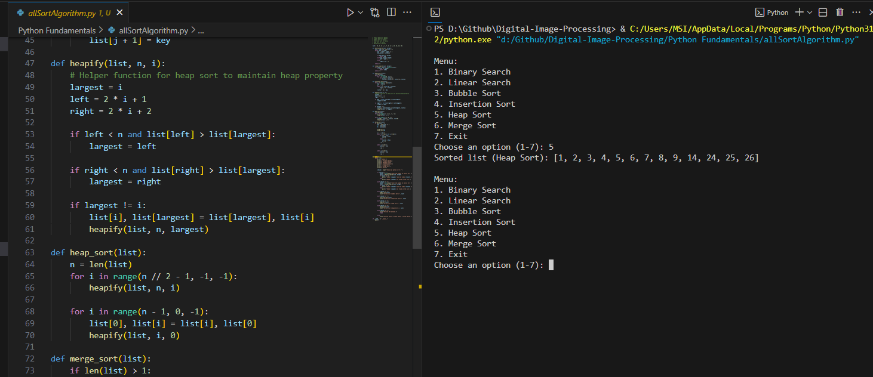

1. **Merge Sort in Python**

